456/1
Mathematics
Paper 1
2 ½ HOURS



ACEITEKA JOINT MOCK EXAMINATIONS 2023
UGANDA CERTIFICATE OF EDUCATION
MATHEMATICS
PAPER 1
TIME: 2½ HOURS

INSTRUCTIONS TO CANDIDATES
- Answer All questions in section A and any five from section B
- Any additional question(s) will not be marked
- All necessary calculations must be done on the same page as the rest of the answer .Therefore no paper should be provided for rough work.
- Graph papers will be provided.
- Silent, non programmable scientific calculators may be used.

SECTION A: (40 MARKS)

- The operation is defined as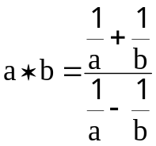. Find the value of 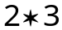
- Use the prime factors of 2744 to evaluate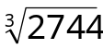.
- Given that matrix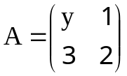and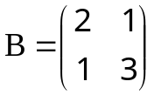and that the determinant of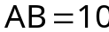, find the value of y.
- The time 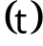taken to build a brick wall is inversely proportional to the number of workers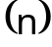.If three workers took 30 hours to build a wall. What time would it take 5 workers to build the same size of wall?
- Solve the inequality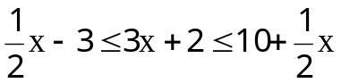.Represent its solution on a number line.
- Make k the subject of the formula ;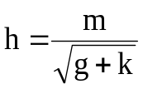 .
- Given that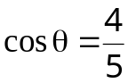and 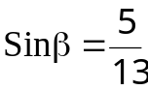and that the 2 angles are acute. Find without using tables or calculators the value of 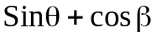
- A team of 7 boys has a mean height of 1.74 m. When Peter joins the group, the mean height becomes 1.76 m. What is Peter’s height?
- The gradient of a line L through points 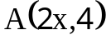and 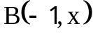 is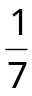.
Find (i)x (ii)the equation of line L.
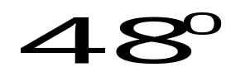

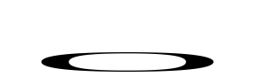




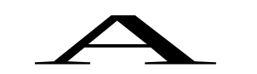
- In the figure below ABCD is a circle with centre O. AB and DC meet at a point E outside the circle .DC = BC and < BCE = 480.

Find the angles;(i)BAD (ii)BDC (iii)BEC

Section B: (60 MARKS)
Attempt any five questions

- (a) Using a ruler and a pair of compass only construct a parallelogram ABCD whose diagonals AC and BD intersect at a point O, given that AC= 16cm and BD = 10.8cm and angle AOB = 120º.
(b) Measure and state the length of AB and BC.
(c) Construct the circum circle of ∆BOC.
(d) Calculate the area of the circumscribed circle.

- The diagram above shows an open water container filled to its brim.
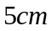
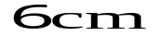

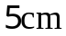

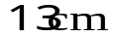

It is made up of a cone and a cylinder. The cylinder has radius 5cm and height 6 cm. The cone has radius 5 cm and slant height of 13 cm.
Calculate
(i)the height of the water container,
(ii) outer surface area of the water container.
(b) Calculate the volume of the water container.
- The table below shows values for 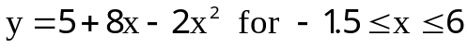
x | -1.5 | -1 | 0 | 1 | 2 | 3 | 4 | 5 | 6
8x+5 |  |  |  |  |  | 29
-2x² |  | -2 |  |  |  |  |  |  | -72
y |  |  |  | 11 |  |  |  | -5

(a)Copy and complete the table above.
(b)Draw the graph of y=5+8x-2x² for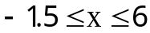.
(c ) Use your graph to solve the equation.
i) 5+8x-2x²=0
ii) -2x²+5x+3=0
(d)State the coordinates of the turning point of the curve y=5+8x-2x²
- (a)The matrix 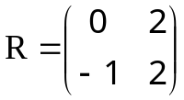maps point 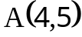on to 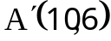.Find a 2 x 2
matrix that maps 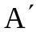back to 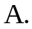
(b)Triangle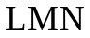whose vertices are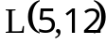,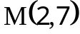and 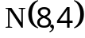 undergoes an enlargement by scale factor, k, about the origin. If the image of is 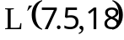
(i)Find k.
(ii)Hence write down the coordinates of 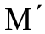and 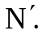
(d)(i)Triangle 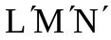undergoes a positive quarter turn about the origin. Use matrices to find the coordinates of the vertices of triangle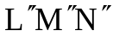,the image of triangle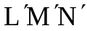.
(ii)Determine a single matrix of transformation that maps directly on to 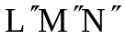.
- (i)An electronic firm makes x Sony and y Philips T.Vs per week. Each Sony T.V requires 20hrs for assembling and 15hours for finishing. Each Phillips T.V requires 30 hours for assembling and 10 hours for finishing. The firm has a maximum of 300 hours available per week for assembling and a maximum of 150 hours per week for finishing. The profit on each Sony and Phillips T.V after selling is Shs. 25000 and 38000 respectively .
- Write down 4 inequalities from the above information.
- By shading unwanted regions represent all the inequalities on the same axes .Use a scale of 2cm to represent 2 Sony T.V s on the x- axis and 2cm to represent 2 Phillips T.Vs on the y –axis..
- Determine how many of each type of T.V should be sold to make maximum profit
- What is the maximum profit?
- The Ogive below shows the distribution of marks obtained by students in a Math test.
(a) Use the graph to estimate the median mark.
(b)Draw a frequency distribution table from the Ogive.
(c)Calculate the average mark using 52 as the working mean.
(d)Calculate the modal mark.

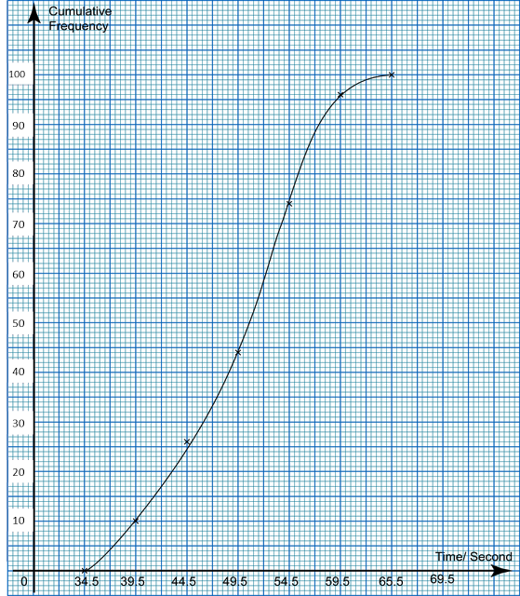
- A sports club has 80 members. For the three activities Swimming (S), Cycling (C) and Weight lifting (W),
8 members take part in all three activities
3 members do not take part in any of the three activities
22 members take part in only S
23 members take part in S and C.
19 members take part in S and W
14 members take part in C and W
x members take part in only W.
The number of members who take part in only Cycling is twice the number of members who take part in only Weight lifting
(i)Draw a Venn diagram to show all of the above information.
(ii) Determine the value of x.
(iii) Determine 𝑛[𝑆∩(𝑊∪𝐶)]
(iv)A member of the club is chosen at random, what is the probability that he takes part in at least 2 activities.

End

